The Chocolate Mill Overlook
The Corner of Roosevelt Avenue and Charles Street
in Central Falls, Rhode Island

Action Steps taken to build the Chocolate Mill Overlook

- Creation of idea

On May 19, 2012 the Sustainable Tourism Lab completed its first working project the “Chocolate Mill Overlook” project. Robert Billington, President of Blackstone Valley Tourism Council, conceived this project in April 2011 after the Confectioners Mill Preservation Society had identified the long-gone William Wheat Chocolate Mill in Central Falls. The Preservation Society selected this location as one of the most significant sites for reconstruction and recreation of an 18th Century Chocolate manufacturing mill. Chocolate was a fundamental part of the early America Industrial Revolution. In the 18th and 19th centuries, chocolate became a standard military provision, commonly issued to soldiers and sailors alike. Though most of the chocolate produced in Central Falls was consumed locally, some of it was sold to outfitters in nearby seaports. Today no “living history” site in the world represents the 18th Century process of making chocolate.

In 2010 the Confectioners Mill Preservation Society was keen to build a museum that would replicate the history of the chocolate mill. The cost of building this site was estimated at $12 million. However, the downturn of the economy at this time forced the Preservation Society to abandon its ambitious plans to build a replica of the William Wheat chocolate factory. Despite the challenges, Billington noted that we have learned too much about the history of the Chocolate Mill in Central Falls to let it go. He then spearheaded the Chocolate Mill Overlook, a project that involved a landscaped recreational area being constructed near the bridge at the corner of Charles Street and Roosevelt Avenue in Central Falls, RI.

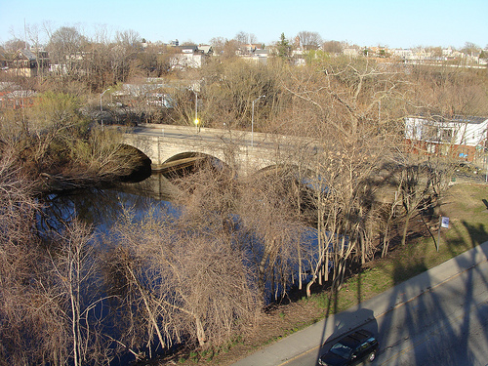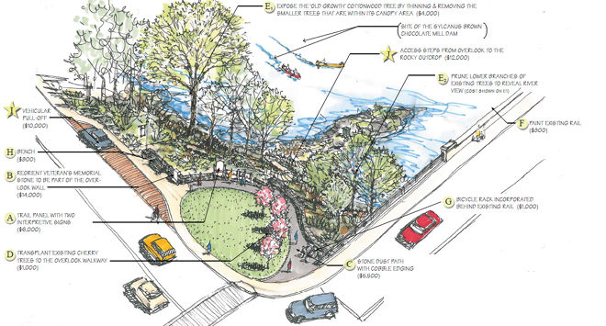

- Cost Estimation

The following chart shows the preliminary estimates for construction of the Chocolate Mill Overlook. Figures include design work, landscaping, and construction. Overages occurred as a result of further information about the location being revealed causing the need for additional interpretive signs to be designed and from adjustments to a few of the landscape design elements.
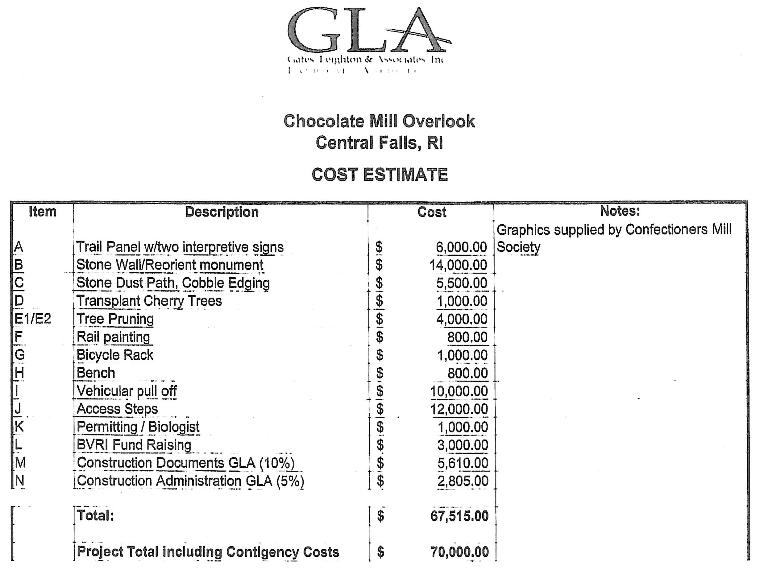

- Feasibility study

The Sustainable Tourism Laboratory (The Lab) and the contracted landscape architects, Gates Leighton & Associates, worked with the Rhode Island Department of Environmental Management, Narragansett Bay Commission, certified arborist Largess Forestry, and David R. Westcott, AICP of Maguire Group, to categorize the site’s vegetation, erosion rates, and flood levels to verifying the possibility of a redevelopment project on the riverbank of the Blackstone River. Furthermore, The Lab outreached to Central Falls city officials to secure land usage, and cost estimates were prepared.

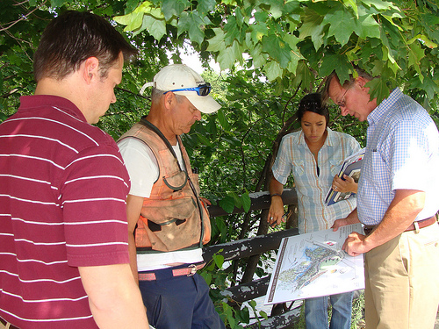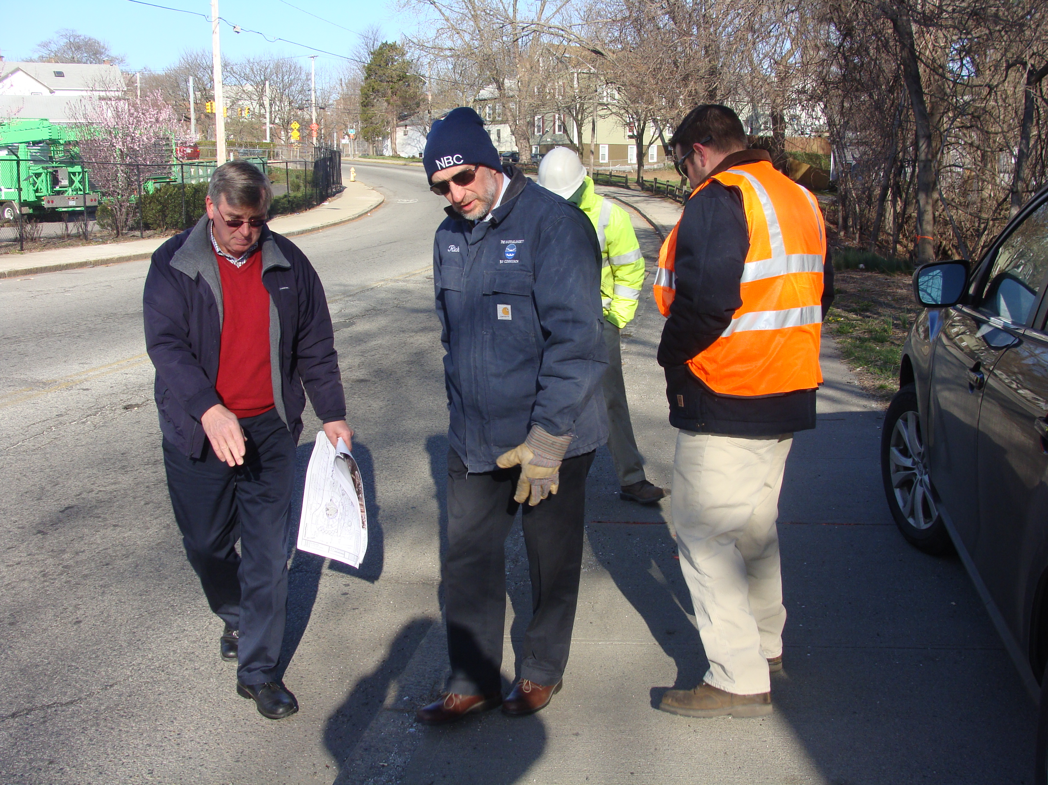
- Fundraising

Mars Inc., and their subsidiary, American Heritage Chocolate, offered a matching grant of $35,000 toward the redevelopment of the historical site in order to tell the story of early chocolate manufacturing in America. An additional matching grant of $35, 000 was awarded by the Rhode Island Department of Environmental Management for this project. Further fundraising was collected through various private organizations and charitable foundations, both in the form of financial and in-kind donations.

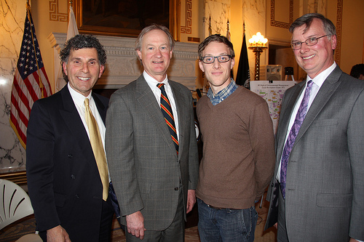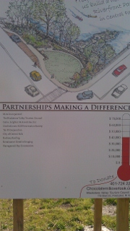

- Secure Permits

The Lab collaborated with the City of Central Falls and the Rhode Island Department of Environmental Management to file the necessary permits to develop an area along the banks of the Blackstone River. All materials were submitted, and permits were approved and recorded into city records.

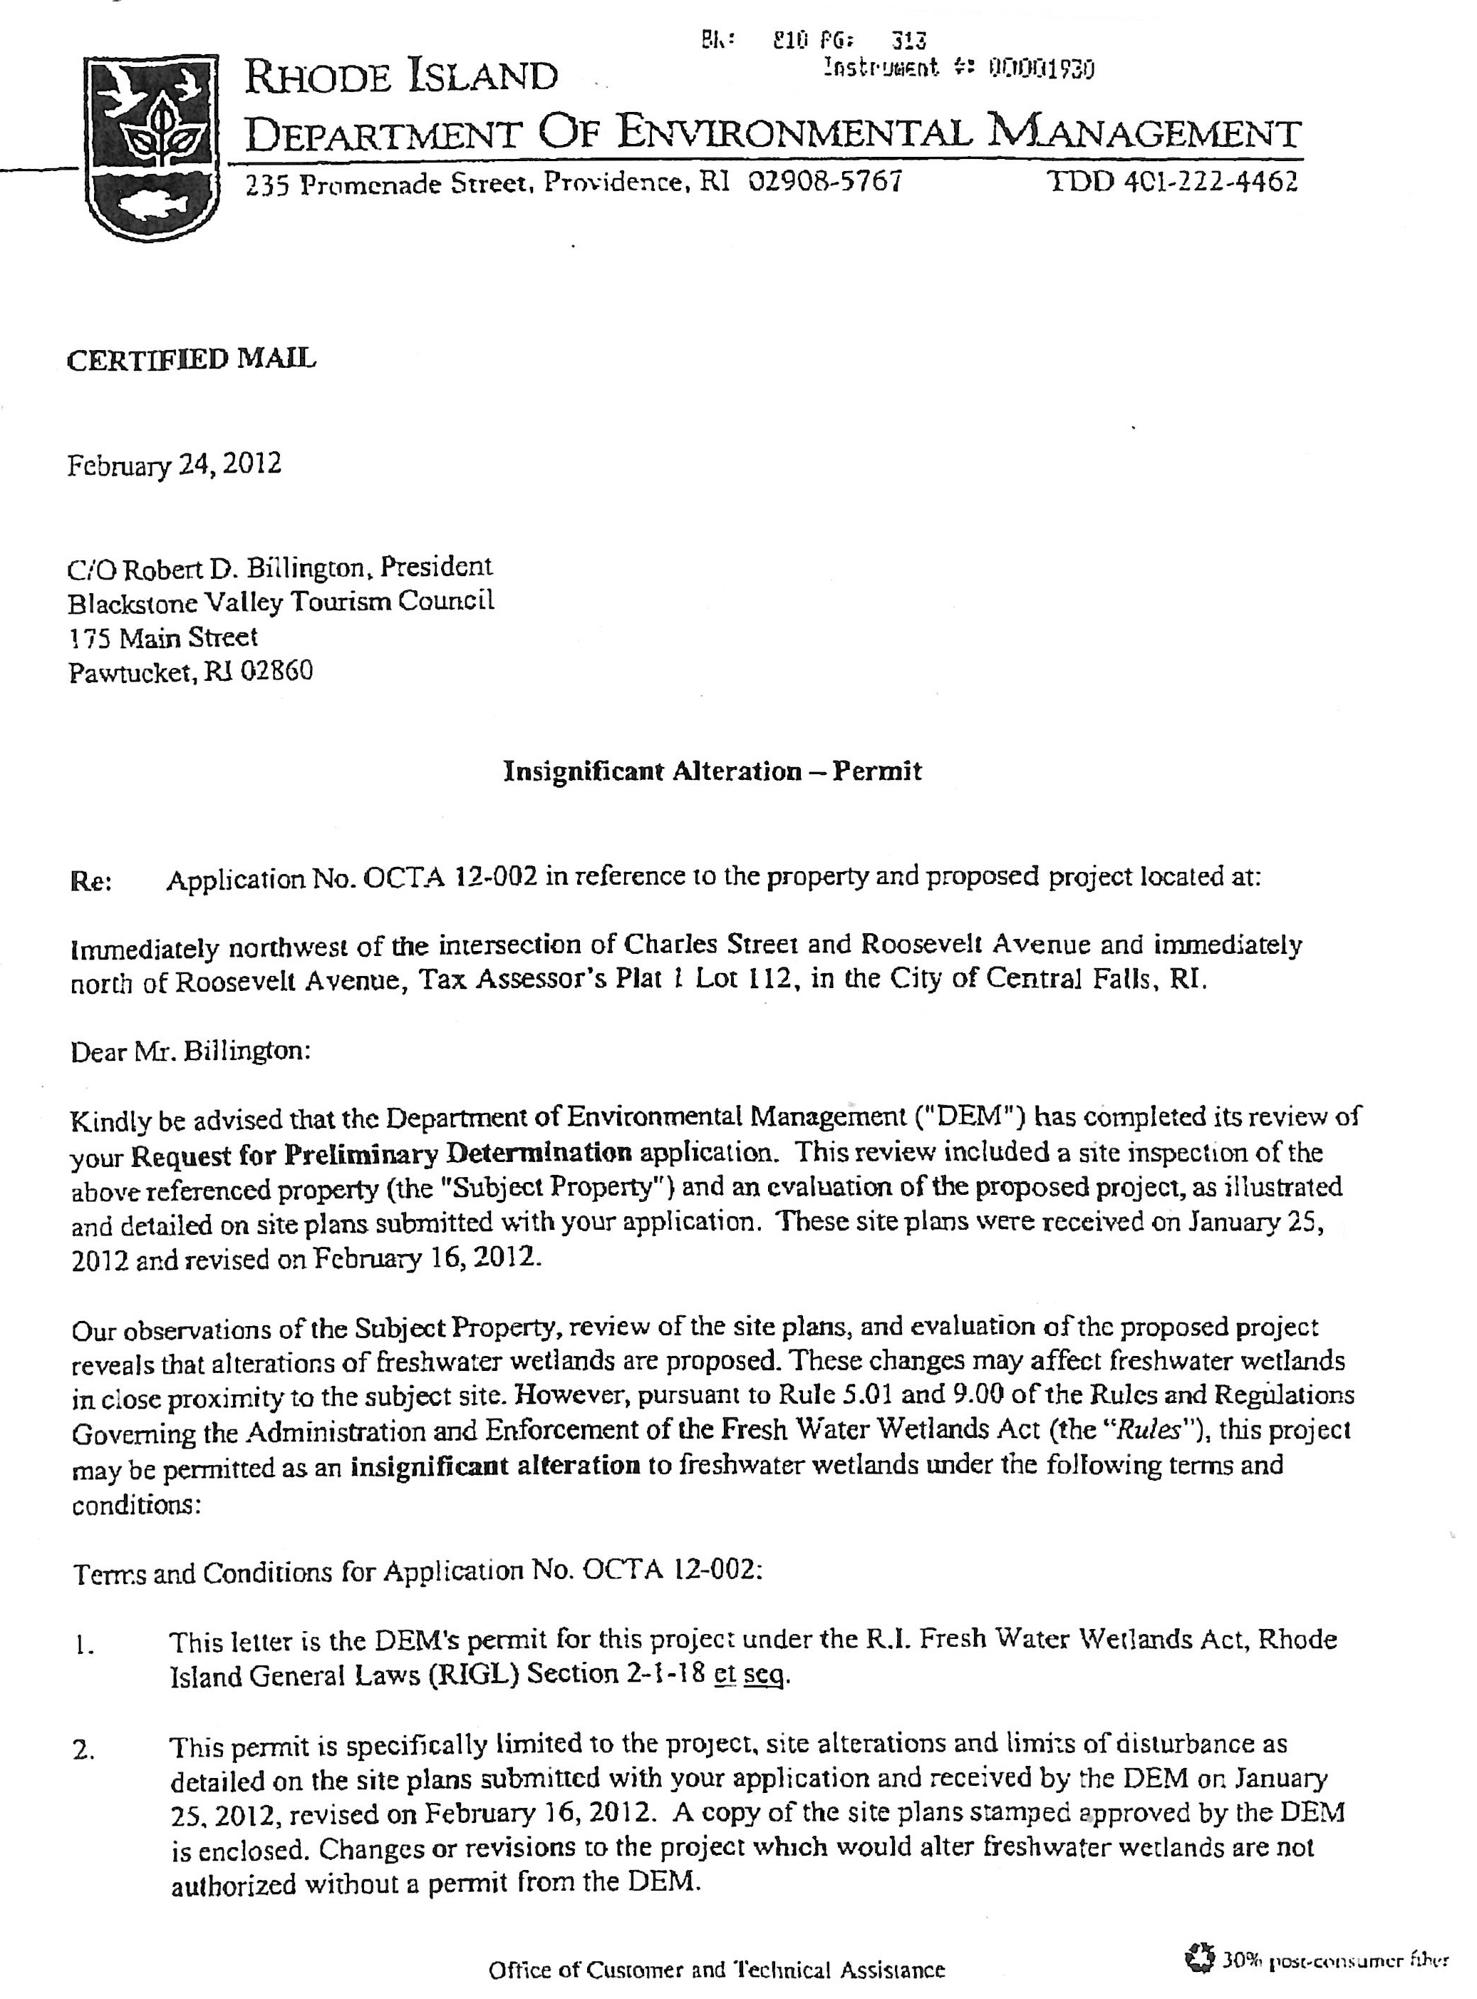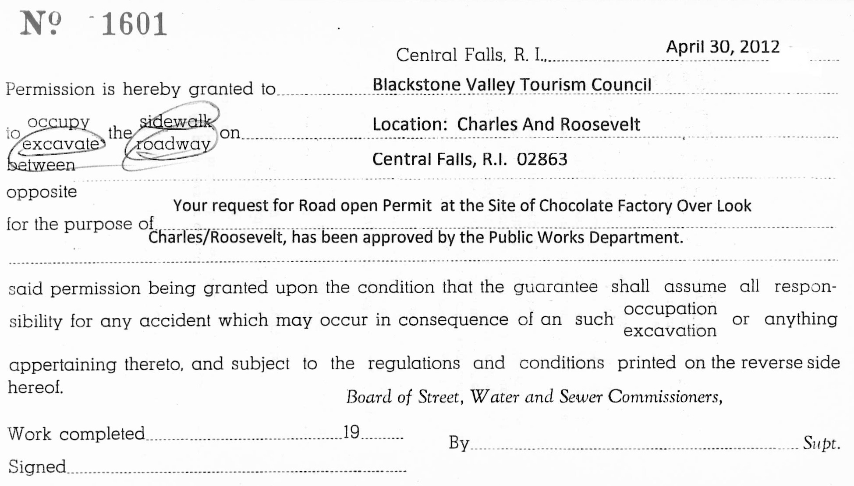

- Construction begins

After site clearing and tree removal by Asplundh Tree Expert Co. and Largress Forestry, the construction of the Chocolate Mill Overlook began on Monday, April 16th, 2012 by contractor David Meloni Landscaping Inc. Construction at the site included building a set of steps down to the Blackstone River to provide river access, a parking area that would accommodate five cars or two buses, a sitting wall, installation of interpretive signs, and landscaping the riverbank. The Central Falls Department of Public Works and a dedicated group of independent contractors assisted in the construction of the Chocolate Mill Overlook. Concurrently, designers at Renaissance Creative Imaging were developing the signs and interpretive panels.

Nearing completion, the students of Central Falls High School came to install a rain garden, and Largess Forestry planted three mature cherry trees along the Roosevelt Avenue side of the park and sixteen cherry saplings along Charles Street to create the Central Falls Japanese Cherry Tree Nursery.

Construction of the Chocolate Mill Overlook concluded on May 18th, 2012 with the installation of the interpretive panels.

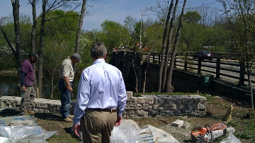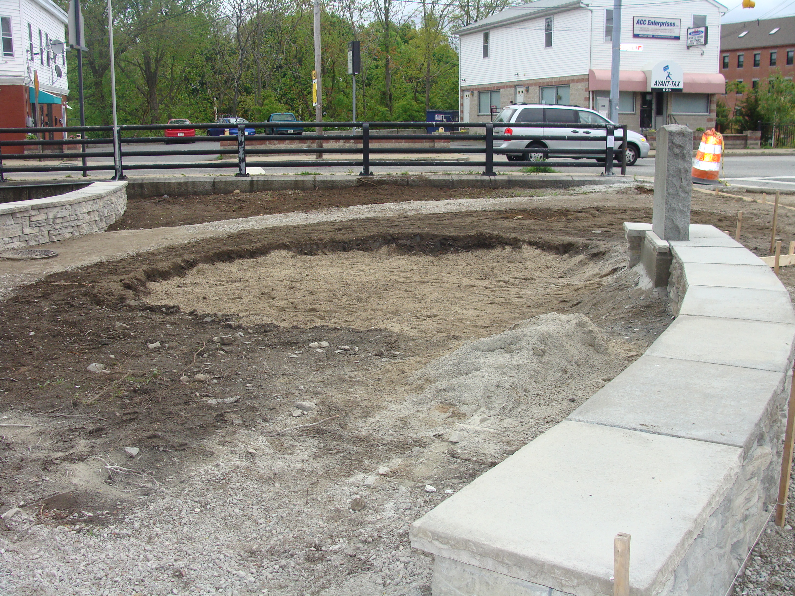

- Completion

The site is now complete and reached its goal to include walkways, sitting areas and a series of stone steps leading down to the river, where residents and visitors to Central Falls could fish or kayak. Hours after the overlook was opened a local artist was spotted painting the beautifully sunlit Roosevelt Avenue Bridge that can now be observed from the river bank due to the redevelopment of this area.

Furthermore, the Chocolate Mill Overlook features large outdoor interpretive panels that tell the story of chocolate manufacturing in Central Falls. Central Falls was once known as “Chocolateville” or “Chocolate Town,” a legacy that has been largely forgotten. With the assistance of the many supports and financial contributors, the Sustainable Tourism Lab has taken a step closer to reclaiming that legacy by telling the story of this important historical site.

Bob Billington hopes that the William Wheat Chocolate Factory museum idea will one day come to fruition as well. He stated that the Chocolate Mill Overlook will be a starting point in telling the story of Central Falls’ unique place as a chocolate maker. The construction of the Chocolate Mill Overlook has provided in-depth knowledge on the subject of chocolate manufacturing and additional information on early industrial usage of the Blackstone River.

From this project, the Chocolate Mill Overlook has led to a larger planning effort entitled the Chocolate Mill Gateway Laboratory, a landscape redevelopment project to enhance the northerly entrance to Pawtucket and Central Falls.

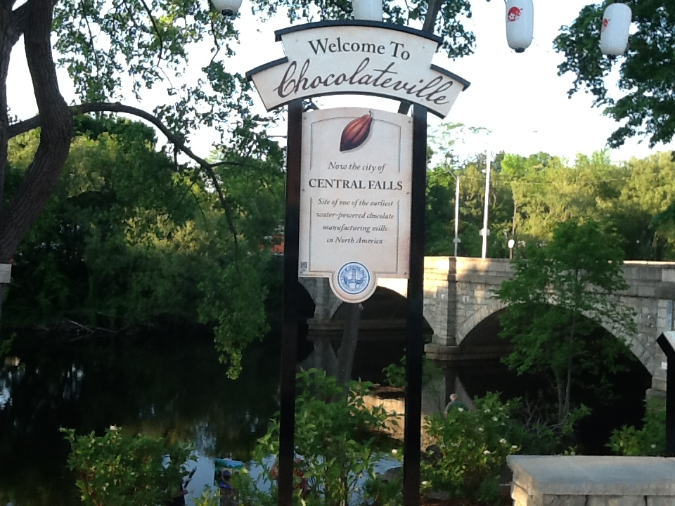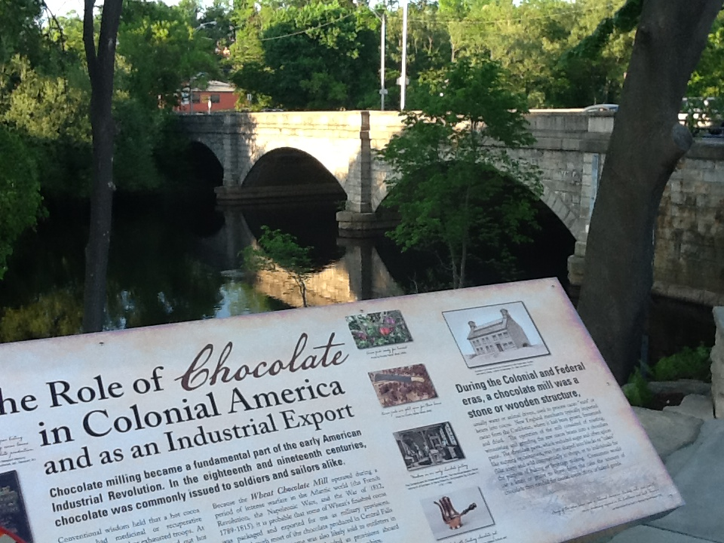

- Celebration

Saturday, May 19th, 2012 marked the unveiling of the Chocolate Mill Overlook. The festivities included a performance by Odaiko New England Drummers, a colonial chocolate demonstration by American Heritage Chocolate, and a speaking program that consisted of Judge Robert Flanders, City of Central Falls, Receiver; David Cicilline, United States Congressman; Betty Crowley, Rhode Island Senator; Takeshi Hikihara, Consul General of Japan in Boston; Kara Fulginiti, Rhode Island Cherry Blossom Festival Princess, 2012; Scott Morris, Washington, DC Cherry Blossom Festival; Brad Figel, Vice President, Public Affairs, Mars, Inc; Jan Reitsma, Executive Director of the John H. Chafee Blackstone River Valley National Heritage Corridor; Eric Whitaker, Confectioner’s Mill Preservation Society; Tim Walker, Ph.D., Associate Professor of History, University of Massachusetts, Dartmouth; Donald Leighton, President, GLA Landscape Architects; Peter Coffin, Blackstone Valley Coalition.

Refreshments were provided and free kayak rentals were offered so guests could experience the park’s river access.

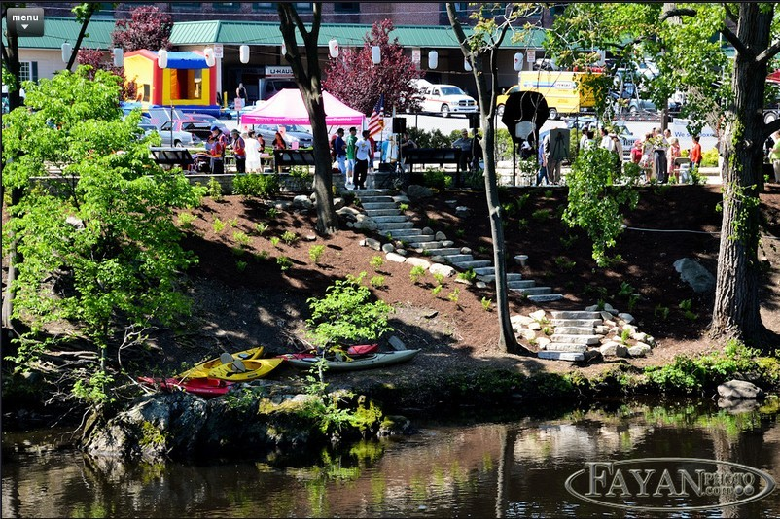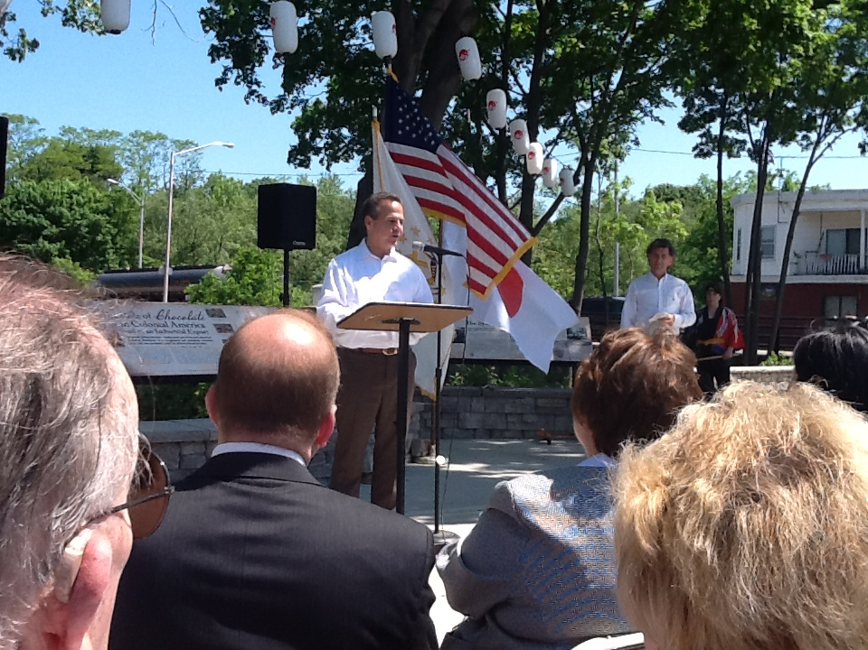
- Acknowledgements

The following is a list of Lab Participants, Financial Supporters who matched the funds of Mars Incorporated, and Contractors who worked on the Mill Overlook.

Lab Participants
- Margarito Aguilar
- Robert Billington, President Blackstone Valley Tourism Council
- Selvin Cante
- Angel Cardona
- Natalie Carter, Blackstone Valley Tourism Council, Inc.
- Glenn Champagne, Central Falls Department of Public Works
- Al Constantino, NRI Stone, Inc.
- Gail Corrigan, Central Falls Chief of Staff
- Brad Figel, Vice President, Public Affairs, Mars Inc.
- Deb Howard, Gates Leighton Associates, Landscape Architects
- Jose Jordan
- Lorraine Joubert, Director, Nonpoint Source Education/URI
- Ranger Kevin Klyberg, Blackstone River Valley National Heritage Corridor Commission
- Mathew Largess, Largess Forestry, Inc.
- Joshua LaPlant, Principal, Grade 9 Transition/Central Falls High School
- Steve Larrick, Central Falls Planning and Economic Development Coordinator
- Don Leighton, Gates Leighton Associates, Landscape Architects
- David Meloni , David Meloni Landscaping Inc.
- Jack McKenna, Renaissance Creative Imaging
- Antonio Miguel, Central Falls Department of Public Works
- Rafael Morales
- Sunny Ng, Tai-O Corporation
- Joseph G. Nield, Central Falls Department of Public Works
- Richard Nievera, Central Falls Department of Public Works
- Kimberly Pinto, Renaissance Creative Imaging
- Elaine Partridge, Central Falls Grants Administrator
- Amanda Sloan, Gates, Leighton & Associates, Landscape Architects
- Students of David Upequi
- James Toomey, Bristol Community College
- David Upegui, Central Falls High School, Science Department
- Tim Walker, Ph.D, Associate Professor of History, University of Massachusetts Dartmouth
- Eric Whitaker, Confectioners Mill Preservation Society
- Louis Yip, Tai-O Corporation

Chocolate Mill Overlook Contractors
- Asplundh Tree Expert Co.
- D. Delfino Concrete & Construction LLC
- David Meloni Landscaping Inc.
- Dion Sign, Inc.
- GLA – Landscape Architecture
- Largess Forestry, Inc.
- Renaissance Creative Imaging Inc.
- Tai-O, Inc.
- Teknicote, Inc.
- Tom Seminick Specialty Products Inc.
- Yard Maintenance Co.

Chocolate Mill Overlook Financial Supporters
- American Heritage® Chocolate; A Mars, Incorporated Brand
- Amvets Post 8 Rhode Island
- Barboza & Sons Roofing and Sheet Metal
- Blackstone River Coalition
- Blackstone River Valley National Heritage Corridor Commission
- Blackstone River Watershed Council
- Confectioners Mill Preservation Society
- Garfield Social Club
- GLA – Landscape Architecture
- J. Drake Turf Farm, Inc.
- Narragansett Bay Commission
- Narragansett Improvement Company
- Nation of Japan
- NRI Stone, Inc.
- Pawtucket Citizens Development Corporation
- Renaissance Creative Imaging
- Rhode Island Council for the Humanities
- Rhode Island Housing
- Storage America
- Tai-O Corporation
- Teknicote, Inc.
- The Blackstone Valley Tourism Council
- The Pawtucket Foundation

